**Bisanara.co**

You are tasked to create the following menu using AVL tree data structure.

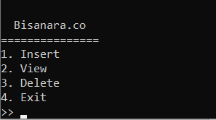

The following menu consist of:

1. Insert

If the user choose this menu, prompt user to input name. Validate the name must be 5 to 90 long. After that, prompt user to input NIM. Validate NIM must exactly have 10 characters. Then, insert the data into AVL tree based on the NIM.

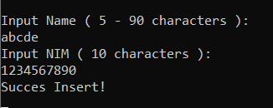

1. View

If the user choose this menu, show all the data in the AVL tree.

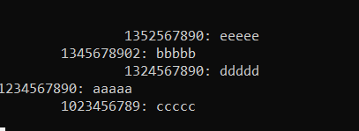

The view menu will show the content of AVL tree in a landscape view of a tree. The child of each node will have an indentation of 1 tab from their parent. According to the image above, the structure of the tree is:

aaaaa(root)

cccccc(root->left)

bbbbb(root->right)

ddddd(bbbbb->left child)

eeeee(bbbbb->right child)

1. Delete

If the user choose this menu, check whether there is a data in the AVL tree. If there are no data in the AVL tree, display “No data”. Otherwise, prompt user to input NIM. Validate NIM must exactly have 10 characters. If the NIM exist, delete the data. Otherwise display “No such NIM”.

1. Exit

If the user choose this menu, quit the program

